Development of an Ultralow-Power Battery-Operated Temperature and Humidity Data Logger
M.A. Pathiraja (2024AE17)

Current Progress
I have developed a compact, ultra-low-power environmental data logger that consumes less than 25 µA in deep-sleep mode. The device reliably records timestamped, calibrated temperature and humidity measurements and supports easy configuration, data download, and analysis through a dedicated PC software tool.
Objectives & Progress
- Long lasting operation on single battery charge (More than one month) – 100% (Projected more than one year)
- Accurate temperature & humidity logging with timestamps. – 100%
- Sensor readings were calibrated – 100%
- Retrieve data from device to PC – 100%
- Change device configuration without re-flashing the firmware. – 100%
- Outdoor‑ready waterproof design. – 100%

- Major Achievements

- Low-Power Optimized Prototype – Fully functional hardware designed for ultra-low energy consumption.
- Calibrated Sensors – Temperature and Humidity readings were calibrated.
- Ultra-low power Consumption: Measured sleep current (22.28 µA) (verified using Nordic PPK2)
- ULP-Optimized Firmware – Includes deep-sleep mode, RTC-based wake-up, encoded data logging.
- Data Retrieval & Config mode – Download stored data and config device settings via UART configuration interface.
- PC GUI Tool – Supports device configuration, data download and formatting, data visualization and analysis
- Rugged Design - IP65 rated Outdoor‑ready waterproof design.

- Device Overview
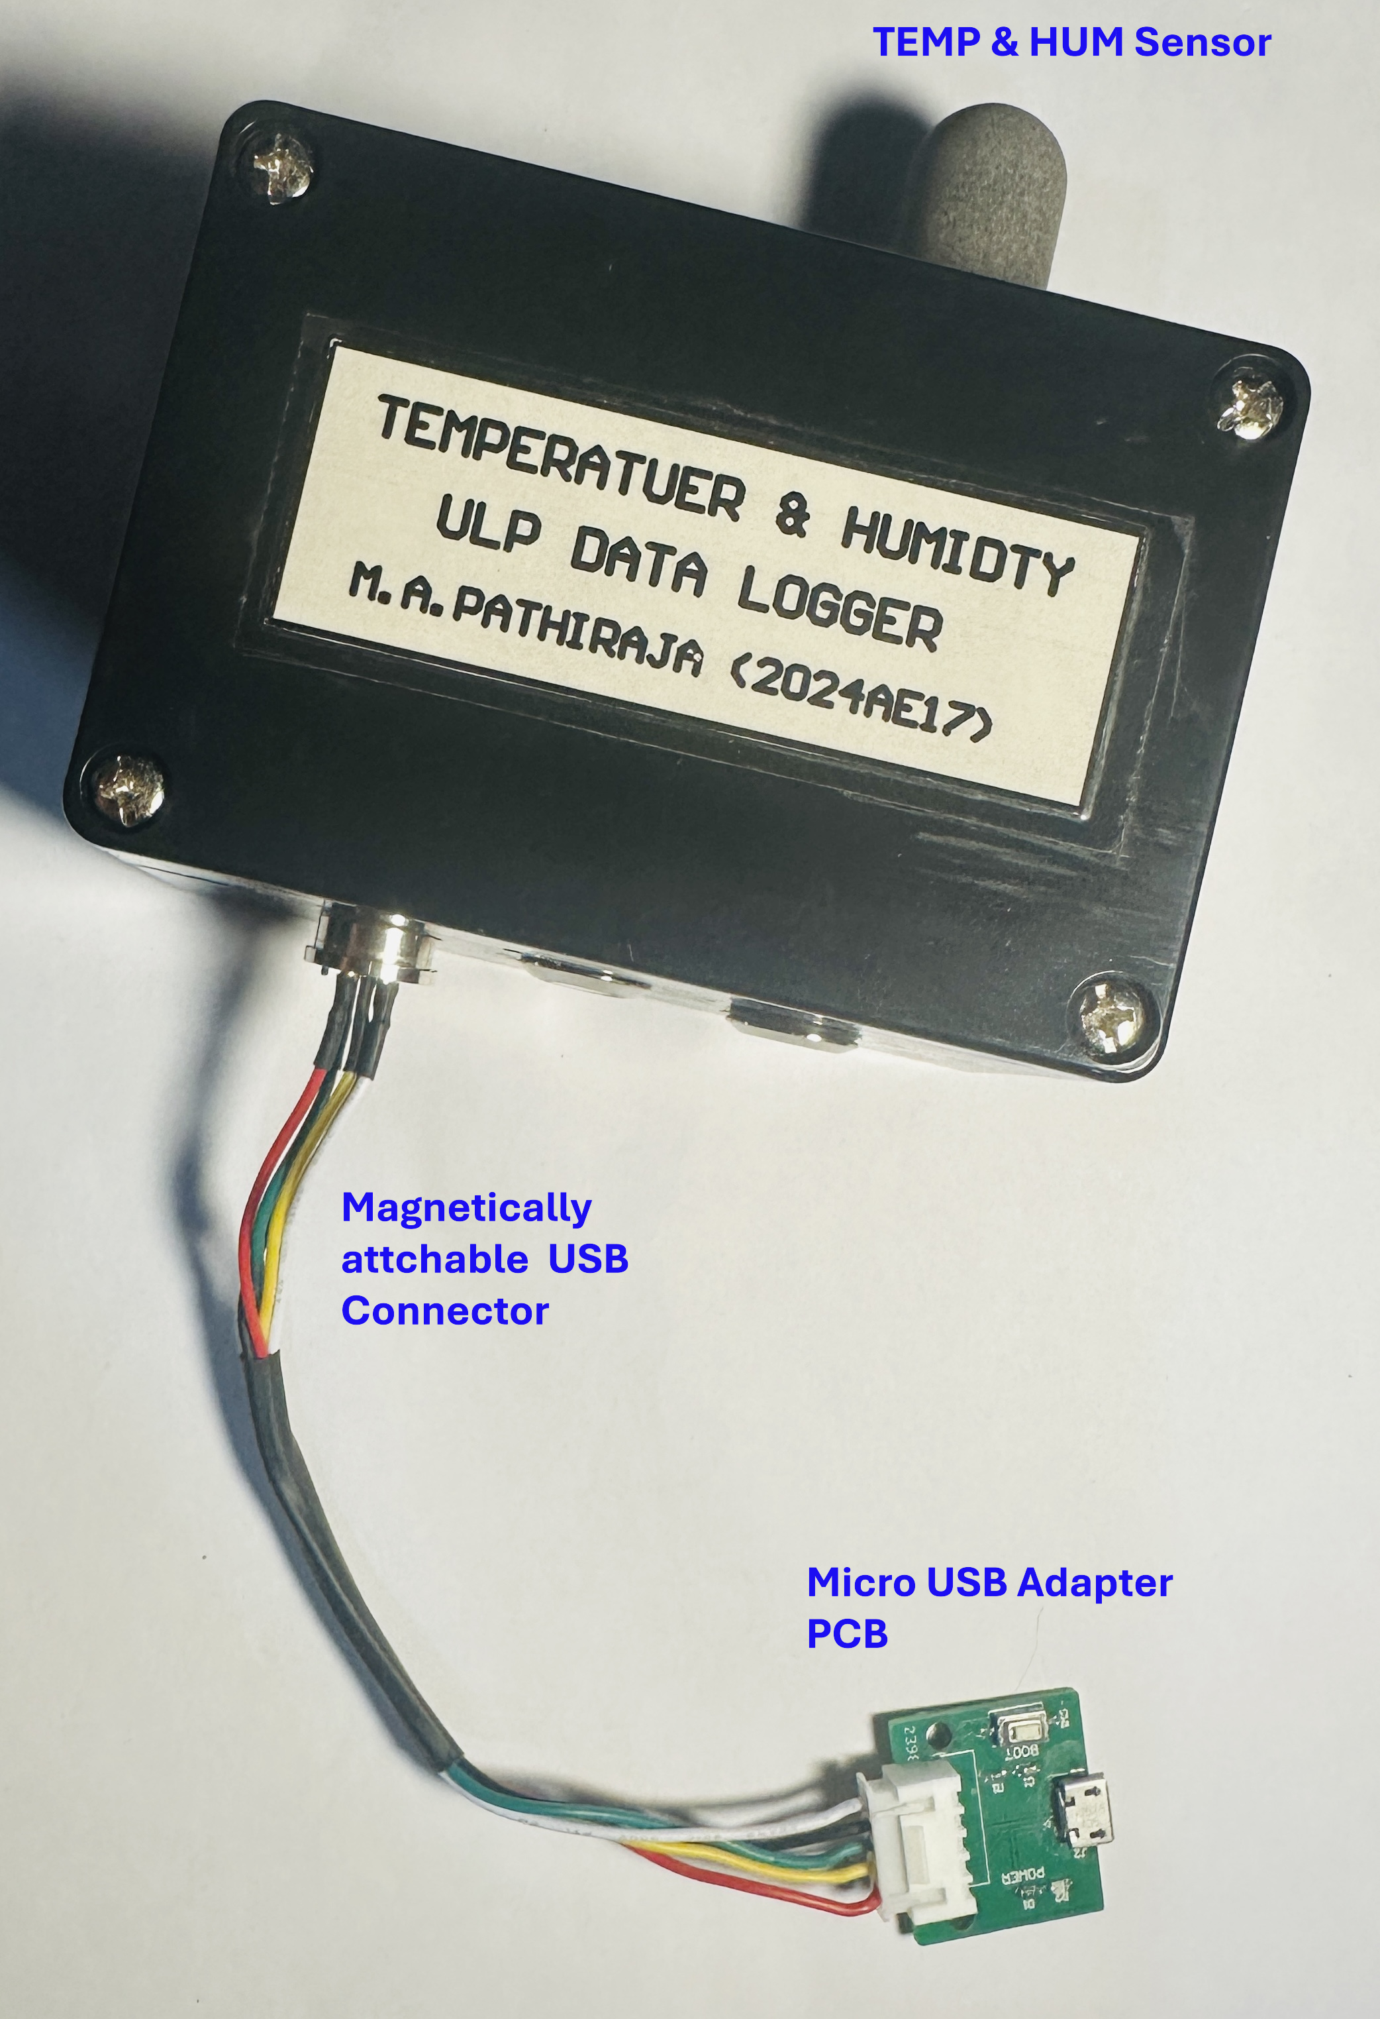
Figure 1: ULP Datalogger TOP view with Magnetic USB adapter

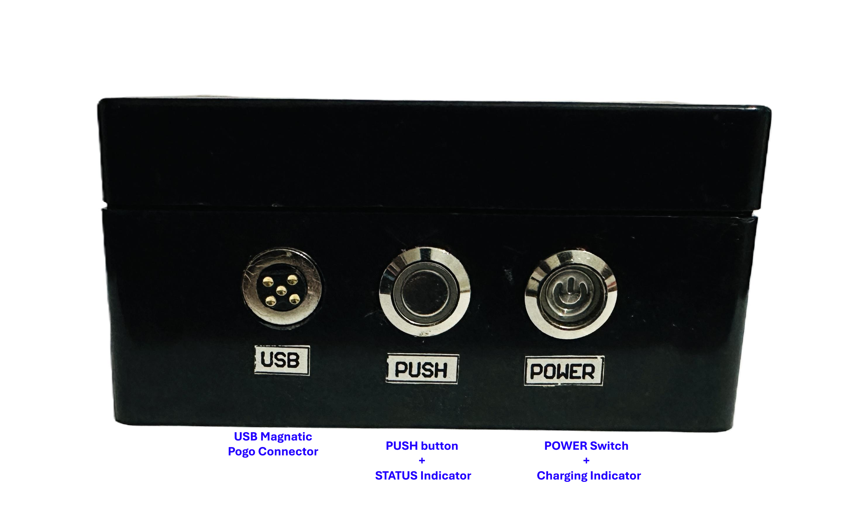
Figure 2: ULP Datalogger Front Panel

3. Hardware Overview
- MCU: ESP32-H2 (RISC-V) with integrated BLE
- Sensor: SHT45 Temperature and Humidity Sensor. (calibrated)
- RTC: RV3028 temperature‑compensated RTC (±1 ppm).
- Storage: Internal flash (11Mbit) and (16Mbit) external flash.
- Power Supply: 3.7 V Li-Po battery with built-in charging and protection circuit
- I/O Interface: Magnetic pogo-pin connector
- Precision ULP ADC: For accurate battery voltage measurement (Calibrated).
- Enclosure: IP65-rated waterproof housing
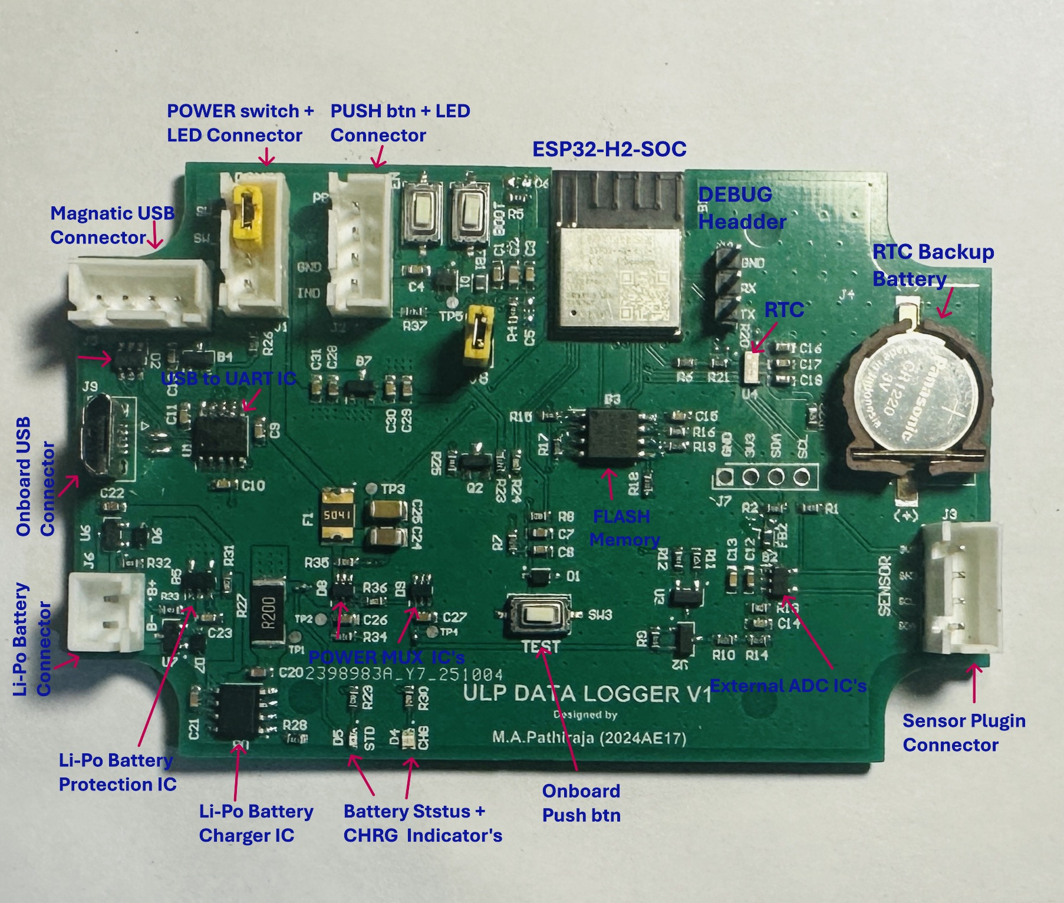
Figure 3: Datalogger PCB assembled
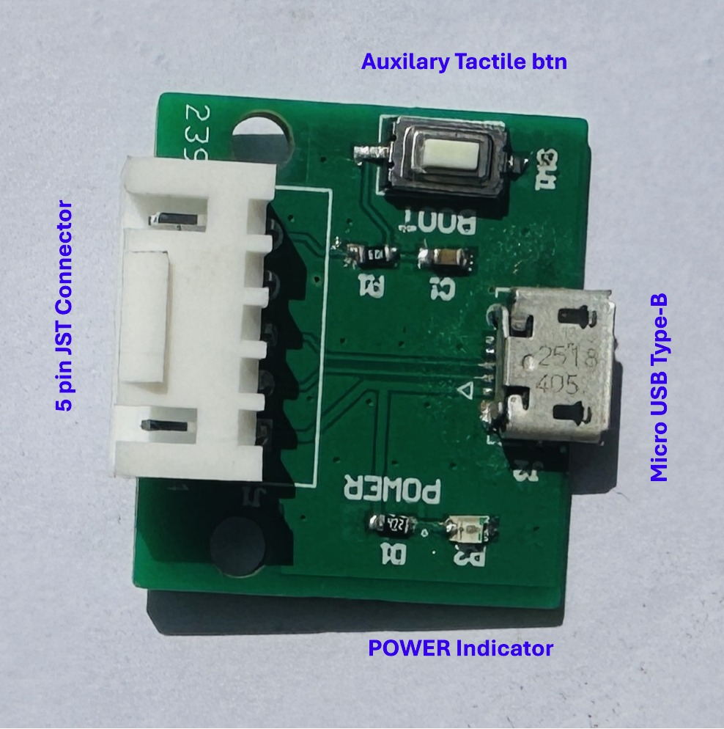
Figure 4: USB adapter PCB Assembled
- Firmware specifications

- Deep Sleep Operation – Minimizes power consumption during idle periods.
- Data Logging – Stores timestamped data records in (7-byte) binary format.
- UART Configuration – Allows device setup and parameter adjustment via serial interface.
- Data Retrieval – Easily view stored records and download to PC.
- Persistent Settings – Retains user configurations across power cycles.
- LED Control – Provides visual status indication through programmable LED behavior.

5. PC GUI Tool
A PC-based GUI tool was developed for easy configuration and analysis of the data logger. It enables users to adjust settings, synchronize the RTC, view live data, and download or manage stored logs. The interface features automatic COM detection and real-time plotting for quick and intuitive operation.

Implemented GUI Features,
- Firmware, Battery, and Storage Information – Shows system version, battery level, and memory usage.
- Set Logging Interval – Adjust data recording frequency as needed.
- RTC Synchronization – Sync device time with PC for accurate timestamps.
- Save Configuration Parameters – Store user-defined settings permanently.
- List and Download Logs – Browse and retrieve recorded data files.
- Format Storage – Clear or reinitialize internal memory.
- Real-Time Plotting – Visualize live sensor data on PC.

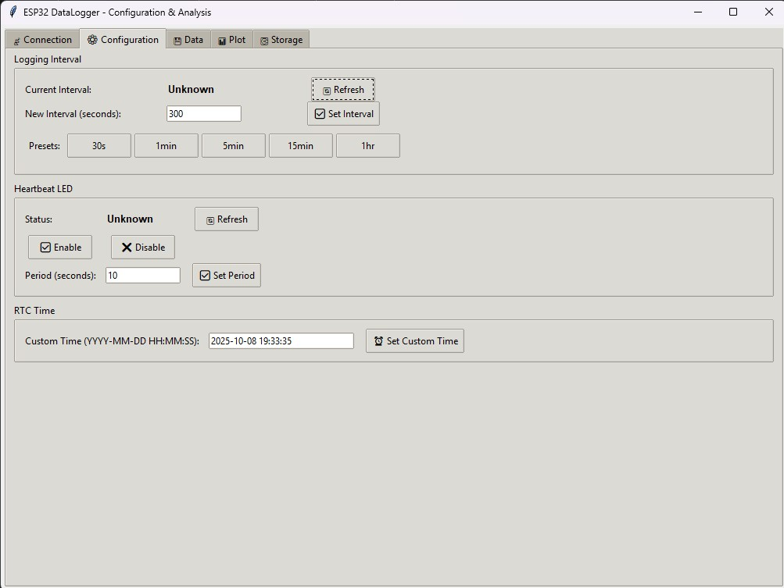
Figure 5: Connection/Configuration UI
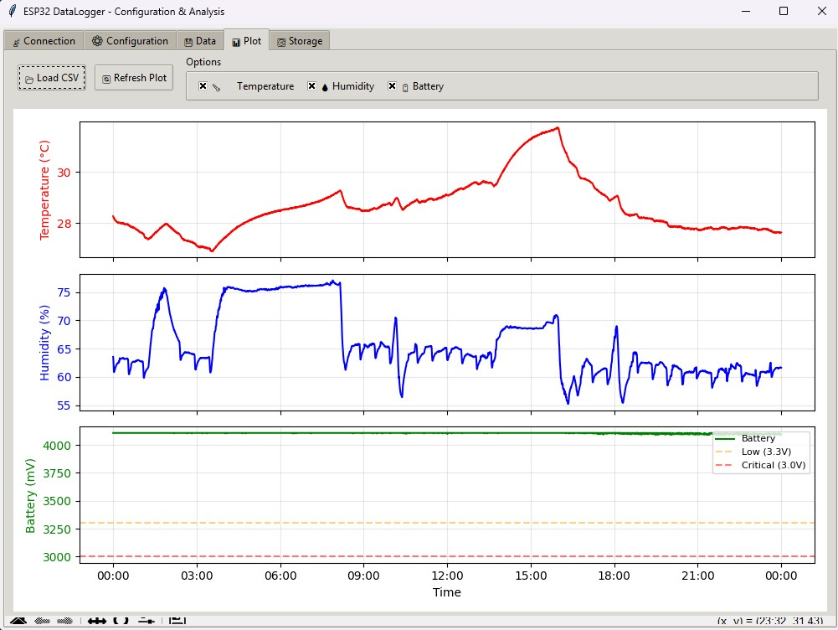
Figure 6: Visualization (Temp/RH/VBAT)

6. Power Consumption
Measurement tool: Nordic PPK2 (source mode , Voltage = 3.7 V).
- Deep‑sleep: ~20.48 µA (max ~22.28 µA).
- Active logging (1 s every 5 min): average ~8.05 mA across the cycle.

Projected battery life (2000 mAh , 5‑min interval): ≈ 1 years (theoretical).
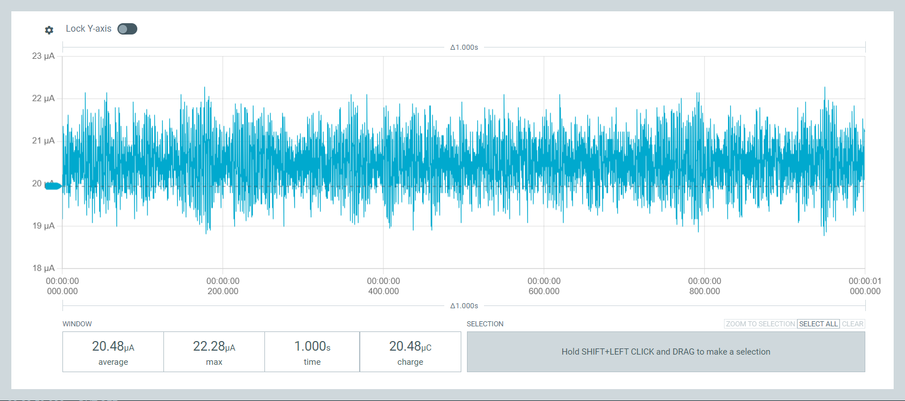
Figure 7: Deep‑Sleep Current Profile (Avg sleep current around 20.48 uA)

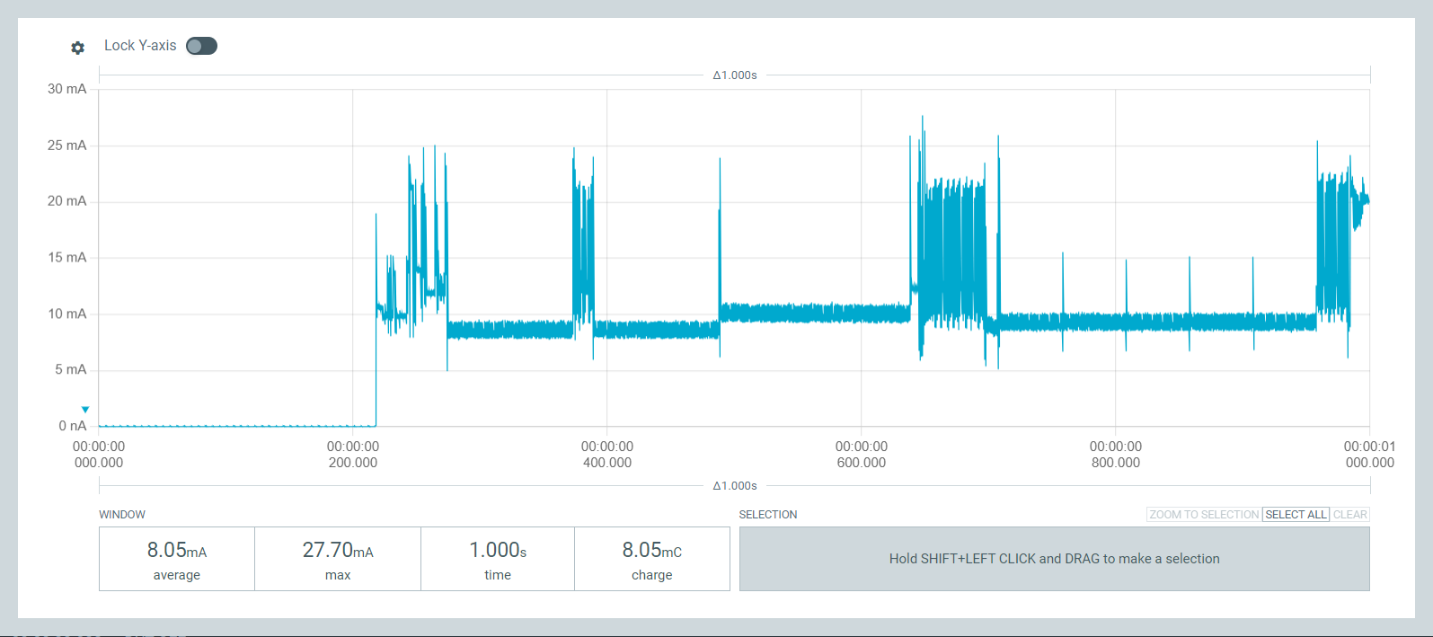
Figure 8: Active Logging Profile (Avg active current around 8.05 mA)

7. Data Storage & Runtime
- Single record size: ≈ 7 bytes
- One-day (5 min sampling): ≈ 2 KB
- Total Storage capacity: ≈ (1.38 MB + 2MB) = 3.38 MB
- Estimated retention: ≈ 1600 days (with 5 % safety margin)
- Maximum possible: ≈ 360 days continuous logging. (From Single battery Charge)

8. Temperature & Humidity Sensor Calibration
The temperature calibration of the SHT45 sensor was performed at an ISO/IEC 17025 accredited laboratory (IMC, Sri Lanka). Five calibration points were evaluated across the operating range of the sensor. The reference thermometer uncertainty is incorporated into the expanded uncertainty reported by the lab.
- Device Under Test (DUT): Temperature and Humidity Logger (SHT45 Sensos)
- Reference Instrument: Digital thermometer with Pt1000 sensor (Reg No:(7424)362-0191A)
- Measurement Range: Temperature :10°C to 50°C , Humidity: 55.00 %RH and 72.00 %RH

Measurement Data (Provided by Laboratory):
i)Temperature Measurement
Table 8.1: Reference Temperature and Device (Sensor) readings with correction and expanded uncertainty (K=2 , for 95% confidence level)
Reference Temperature (°C) | Device Reading (°C) | Correction (°C) | Expanded Uncertainty, U (°C)
9.79 | 10.33 | −0.54 | ±0.20
19.60 | 20.06 | −0.46 | ±0.20
29.67 | 29.91 | −0.24 | ±0.20
39.90 | 40.35 | −0.45 | ±0.20
49.89 | 50.28 | −0.39 | ±0.20

ii) Relative Humidity Measurement
Table 8.2: Reference Humidity and Device (Sensor) readings with correction and expanded uncertainty (K=2, for 95% confidence level)
Reference Humidity (%) | Device Reading (%) | Correction (%) | Expanded Uncertainty, U (%)
55.00 | 53.21 | 1.79 | ±3
72.00 | 73.15 | -1.15 | ±3

i) Temperature calibration

A linear regression was performed to relate Device temperature reading to true reference temperature,
Performed linear regression to model:
${ T}_{Corrected}=m ×T_{device}+b$ (01)
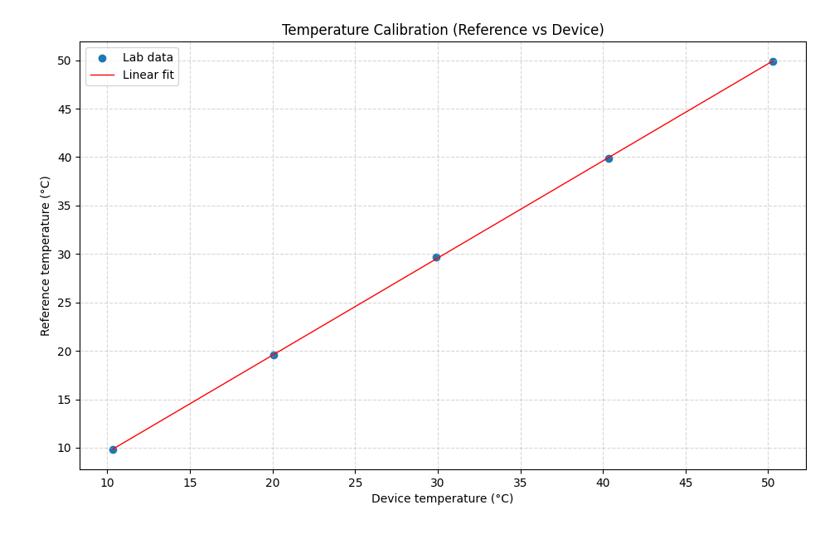
Figure 9: Calibration Plot Showing Device vs. Reference Temperature with Linear Fit
Best-fit parameters:
- Slope (a): 1.00302
- Offset (b): -0.5073 °C
- Coefficient of determination (R²): 0.9999
Residual statistics
- Mean residual: 0 °C
- Standard deviation: 0.101167 °C
- Maximum absolute residual: 0.176835 °C

Uncertainty Calculation

The lab guarantees the reference temperature is correct within ±0.20 °C with 95% confidence. [multiplying the combined standard uncertainty by a coverage factor k = 2]

Therefore, Lab Reference standard uncertainty = 0.10°C

Calibration model Uncertainty (S.D of residuals) = 0.101167 °C

The Lab reference uncertainty and model fitting uncertainty are independent.

Combine them using root-sum-of-squares (RSS):
(02)
$$u_{c}=\sqrt{u_{lab}^{2}+u_{modle}^{2}}$$
Where, $u_{lab}= 0.1$°C$, u_{modle}=0.101167 °C$

Substitute values:
$$u_{c}=0.1414 °C$$

Therefore, uncertainty expanded (k=2 for 95% confidence) $U=2 ×0.1414 °C=0.2828°C$

Fitted model with uncertainty:
(03)
$${ T}_{Corrected}(°C)=(1.00302 ×T_{device }(°C)-0.5073 ) ±0.28°C$$

ii) Relative Humidity calibration
The accredited laboratory provided only two calibration points,

Since only two points were provided, a 2-point linear calibration was derived as ,
(04)
${ RH}_{Corrected}=m ×{RH}_{device}+b$
The slope m and intercept b were calculated directly using,
(06)
(05)
$$m=\frac{R_{2-}R_{1}}{D_{2}-D_{1}}=0.8525$$
$$b=R_{1}-m×D_{1}=9.6354$$
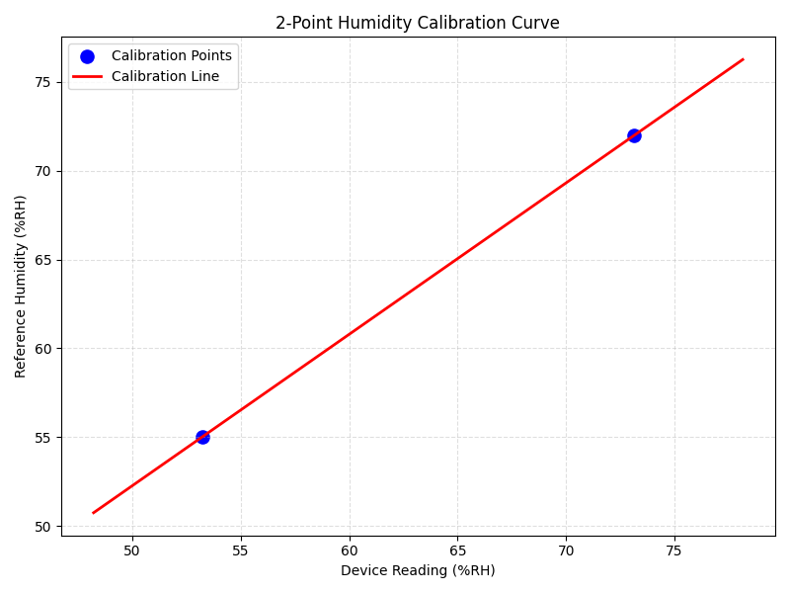
Figure 10: Two-Point Humidity Calibration Curve Showing Device Readings vs. Reference Relative Humidity with Fitted Linear Model

Uncertainty Calculation

The lab guarantees the reference relative humidity is correct within ±3 %RH with 95% confidence. [multiplying the combined standard uncertainty by a coverage factor k = 2]

Therefore, Lab Reference standard uncertainty = 1.5 % RH

The fitted model itself contributes no statistically estimable additional uncertainty (u_fit ≈ 0 %RH, artefact of 2-point line).

Therefore , Calibration model Uncertainty (S.D of residuals) = 0 % RH

The Lab reference uncertainty and model fitting uncertainty are independent.

Combine them using root-sum-of-squares (RSS):
(07)
$$u_{c}=\sqrt{u_{lab}^{2}+u_{modle}^{2}}$$
Where, $u_{lab}= 1.5 \% RH , u_{modle}=0 \% RH$

Substitute values:
$$u_{c}=1.5 \% RH$$

Therefore, uncertainty expanded (k=2 for 95% confidence) $U=2 ×1.5 \% RH=3 \% RH$

Fitted model with uncertainty:
(08)
$${ RH}_{Corrected}(\%RH)=(0.8525×{RH}_{device }(\%RH)+9.6354) ±3\% RH$$

9. ADC Calibration (Battery Voltage measurement)
The MCP3021 (12-bit) ADC was used to measure the battery voltage in the custom ESP32-H2 data logger hardware.
- Device Under Test (DUT): Custom PCB with ESP32-H2 and MCP3021 ADC
- Reference Instrument: Digital Multimeter (DMM, ±25mV at range (9.999V))
- Voltage Source: Bench DC power supply
- Measurement Range: 3300–4300 mV

Measurement Data:
Multiple voltages measured (Supplied from Bench power supply in range 3.3V to 4.3V) simultaneously by the DMM and ADC (uncalibrated firmware output).

Table 9.2: Reference Voltage and ADC computed Voltage in mV
Reference Voltage (mV) [±25 mV] | ADC Measurement (mV)
3302 | 3317
3401 | 3409
3501 | 3506
3601 | 3606
3701 | 3703
3804 | 3802
3903 | 3899
4001 | 3999
4102 | 4098
4201 | 4201
4304 | 4294

Linear Regression Model
A linear model was fitted to relate the ADC reading (input) to the true reference voltage,
$$V_{Calibrated}=a ×V_{ADC}+b$$
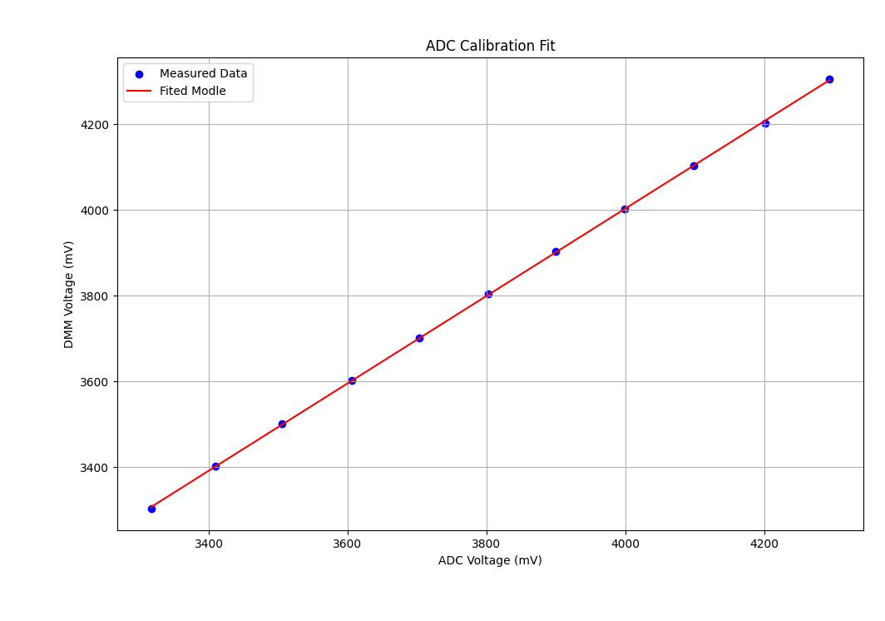
Figure 11: Calibration Plot Showing Device vs. Reference voltage with Linear Fit
Best-fit parameters:
- Slope (a): 1.0188
- Offset (b): –72.6815 mV
- Coefficient of determination (R²): 0.999917

Residual statistics
- Mean residual: ≈ $4.5×{10}^{-13}$mV → effectively 0 mV
- Standard deviation: 2.89 mV
- Maximum absolute residual: 6.3 mV (at 4201 mV point)

Note: -
After calibration, the ADC readings follow the model with max error ≈ ±6.3 mV, but the absolute accuracy is limited by the DMM’s ±25 mV.

Fitted model with uncertainty:
$$V_{Calibrated }\left(mV\right)=1.0188 ×V_{ADC}(mV)-72.6815 ±25 mV$$

